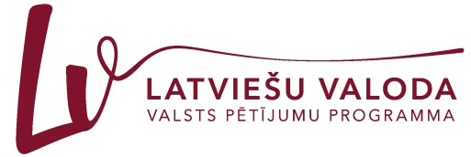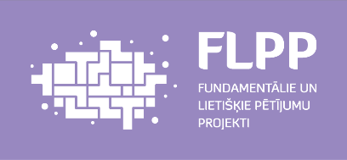

Liepāja University
Faculty of Humanities and Arts
and
Kurzeme Institute of Humanities
invite you to participate in

the 24th International Scientific Conference
“The Word: Aspects of Research”
which will be held at Liepāja University
28 November–29 November 2019

Please submit your application online filling in the application form on the homepage https://vards.liepu.lv/ by 7 October 2019.
The acceptance letter will be sent by 21 October 2019.
Two thematic workshops are scheduled for the conference – the research of scientific language (in cooperation with the project “Intra-lingual Aspects of the Latvian Scientific Language”) and the use of digital technologies in linguistic research (in cooperation with the Latvian Association of Applied Linguistics).
Working languages: Latvian, Lithuanian, English, German, and Russian.

Conference fee:
- participants with papers EUR 70.00 (till November 7, 2019) or EUR 80.00 (after November 7, 2019 or on the conference days);
- each co-author who does not participate in the conference EUR 35.00 (till November 7, 2019) or EUR 40.00 (after November 7, 2019 or on the conference days)*;
- participants without papers who attend all the conference events EUR 30.00.

Please transfer your participant fee by 7 November 2019 to the following account:
Liepāja University
Lielā iela 14, Liepāja, LV-3401
Reg. No.: LV90000036859
Account: LV45TREL9150190000000
Please indicate: your first name, surname, conference “The Word: Aspects of Research” participant fee, ECC – 21499

Dr. Philol. Ieva Ozola, Head of the Scientific Committee
Dr. Philol. Linda Lauze, Head of the Organising Committee

Address of the Scientific and Organising Committee:
Liepāja University
Faculty of Humanities and Arts
Kūrmājas pr. 13
Liepāja, LV-3401
Mg. philol. Sigita Ignatjeva, secretary
Phone: (+371) 63483781
e-mail: balti@liepu.l

Please find the information on hotels in Liepāja at http://liepaja.travel/en/sleep/city/hotels/
Liepāja University Students‘ hostel – Liepāja, Ganību iela 36\48 (phone: 24243933; e-mail: hostel.oagprojekti@gmail.com).
* If the co-author participates in the conference, the full participation fee shall be paid. If a conference participant is the author of several papers/articles, additional EUR 35.00 should be paid for each paper/article (starting with the second paper/article).

